Remembrance Day Memory Project Part 1

1. What date is Remembrance Day?

2. Why was this date chosen?

3. Canada has participated in a number of wars or conflicts. Name 3.

a.

b.

c.

4. Why do we wear poppies on Remembrance Day?

5. Who was John McRae and what is he remembered for?

6. Draw a picture of what Remembrance Day means to you. Please make it school appropriate.

Remembrance Day Memory Project Part 2

An artifact is a item made by humans which reminds us about a certain period in time. Choose one of the artifacts that you saw in class or bring from home to research and create a short presentation about it. You will share the presentation and the artifact with the class.

Research project plan

1. What artifact did your choose? (write name or brief description here).

2. Why did you choose this artifact?

3. What question will you answer? (You may choose to answer the question with the artifact or ask one of your own. If you would like to answer your own, it must be approved by the teacher first).

3. How do you plan to find out more information about it?(internet research, books, talk to someone)

4. What did you find out? You may attach Artifact sheet or write answers in here.

a.

b.

c.

d.

e.

Put your findings into a paragraph, essay, poem, story, picture, video or powerpoint to share with the class.

This project is due on Friday, November 8th.

You will receive a mark out of 100 based on the Marking Guide below.

Marking Guide for Remembrance Day Memory Project

Criteria | Marks Available | Your Mark
Listening | 10
On Task | 10
Asked for help when needed | 10
Answered Part 1 questions appropriately | 15
Answered Research questions appropriately | 15
Finished Memory project | 10
Memory project | 20
Presentation | 10
Total Marks | 100

Time Line for Remembrance Day Memory Project

Monday, Nov. 4th – 1:15 to 2:15
1. Discuss Memory Project. 5 minutes
2. Give out handout and discuss. 10 minutes
3. Watch Remembrance Day powerpoint. 30 minutes
4. Work on Part 1 questions. 15 minutes – 40 minutes (students may continue to work during Homework and EFT - will be homework if not completed in class.)

Tuesday, Nov. 5th – 1:15 – 2:15
1. Short sharing on life of John. S. Halen – RCAF veteran. 10 minutes
2. Look at artifacts. 20 minutes
3. Discussion about artifacts. 10 minutes
4. Choose artifact to research and complete research questions 1, 2 and 3. 10 – 40 minutes (students will continue to work during Homework and EFT until questions are complete)

Wednesday, Nov. 6th
11:30 – 12:15 (Library Prep)
1. Library - Short sharing of artifact and question chosen and work completed to date. 10 minutes
2. Library - Continue research and recording what you found out. 30 minutes

1:15 – 2:15 (Classroom)
3. Short discussion on methods to present information. 10 minutes
4. Choose method to present information and fill out presentation organizer. 15 minutes
5. Share choice with class. 5 minutes
6. Continue research or begin presentation work. 15 - 40 minutes (students may continue to work during Homework and EFT if they choose)

Thursday, Nov. 7th
10:45 – 11:30 (Library Prep in Classroom)
1. Snack and sharing about project. 10 minutes
2. Work on presentation. 30 minutes
3. Get ready for spelling. 5 minutes

1:15 – 2:15 (Classrom)
1. Update class on project to date. 10 minutes
2. Discussion on how to present to the class. 10 minutes
3. Complete Memory Project or rehearse presentation for tomorrow. 40 – 70 minutes (students will continue to work during Homework and EFT if they are not finished project - unfinished projects will be taken home for homework.)

It is expected that the finished project will be ready for presentation on Friday – before and after our Remembrance Day assembly.
Picture Frame 1 - Artifact 1: Picture of John S. Halen

Big Question - What was John Halen's involvement in WW2?

1. When did he enlist?

2. How old was he?

3. What job did he do?

4. What education did he need to do the job?

5. What rank did he have?

6. When did he leave the RCAF?

Picture Frame 1 - Artifact 2: Squadron Badge
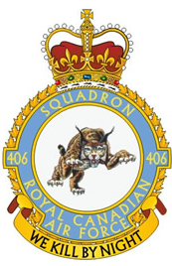
1http://www.canadianwings.com/Squadrons/squadronDetail.php?No.-406-Squadron-65
Big Question – What was the RCAF Squadron's role in WW2?

1. What was the name and number of the Squadron?

2. What was their motto?

3. What was the squadron's job?

4. How did they achieve this?

5. What roles were there in the Squadron?

Picture Frame 1 - Artifact 3: RCAF Badge

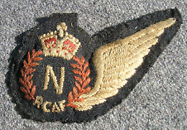
Big Question – What was the RCAF's role in WW2?

1. What does the initials R.C.A.F. stand for?

2. What year did the RCAF begin?

3. Where did training take place during WW2?

4. What countries were RCAF squadrons stationed in during WW2?

5. What types of planes did they fly?

Picture Frame 1 - Artifact 4: Navigator's Badge

Big Question – Why was the Navigator's role important in the RCAF?

1. What did a navigator do?

2. How long was their training?

3. Where did they receive their training?

4. What kind of knowledge and equipment did they need to have?

5. Are navigators still as important today?

Picture Frame 2 – Artifact 5

Big Question – Why are medals given to veterans?

1. What are the names and meaning of each of the medals?

Name | Purpose

2. Where are the medals to be worn?

3. How are the medals to be worn?

4. When do people wear medals?

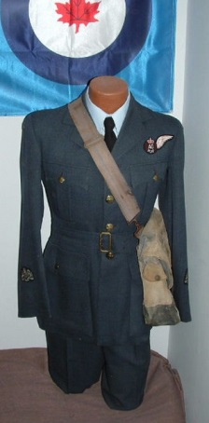
2http://www.warrelics.eu/forum/military_photos/aviation-history-general/252505d1318860746-my-rcaf-uniform-display-rcaf-warrant-officer-display.jpg
Uniform Jacket – Artifact 6

Big Question – Why do soldiers wear uniforms?

1. What type of uniform jacket is this?

2. When and where was it made?

3. What type of badges and insignia do jackets usually have?

4. When and wear would a soldier wear his jacket?

5. What else would a soldier wear with the jacket?

Flight Jacket – Artifact 7

Big Question – What clothing did pilots and navigators need to do their job?

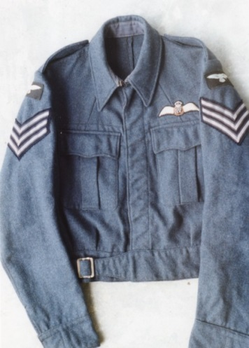
1. When did the flight crew wear this jacket?

2. When and where was the jacket made?

3. What type of badges and insignia do jackets usually have?

4. What other clothing would the flight crew wear?
3http://wing.chez-alice.fr/RAF/RAF_clothing.html

5. How could this clothing help the flight crew do their job?

http://wing.chez-alice.fr/RAF/RAF_clothing.html

Flying Boots – Artifact 8

Big Question - What equipment did pilots and navigators need to survive?
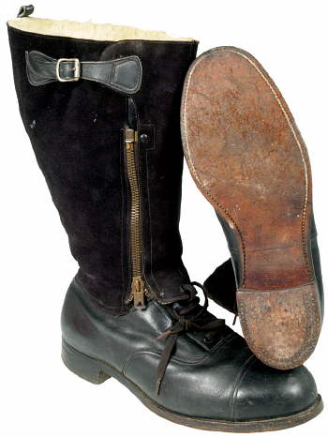
4http://wing.chez-alice.fr/RAF/RAF_clothing.html
1. What are these boots made of?

2. Why would they be made of this material?

3. What is special about these boots?

4. Why was it important?

5. What can be hidden in the boot?

http://wing.chez-alice.fr/RAF/RAF_clothing.html
Artifact 9 - de Havilland Mosquito B MK XX photograph

Big Question – What was Canada's role in in supporting war efforts?
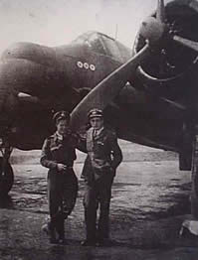
1. Describe the Mosquito aircraft.

2. Why did this make it good at its job?

3. Where was it built?

4. About how many planes were built?

5. How many flights did John Halen fly in a Mosquito aircraft?

http://www.bombercommandmuseum.ca/mosquito.html

Artifact 10 – Embroidered Tea Cloth

Big Question – How did WW2 change our world?

1. What injury did John Halen receive?

2. How was he injured?

3. Who would have taken care of him?

4. What drug was invented that allowed him to survive?

5. What did he do while he was recovering in hospital?

http://www.acs.org/content/acs/en/education/whatischemistry/landmarks/flemingpenicillin.html#P64_16492
http://www.redcross.org.uk/About-us/Who-we-are/Museum-and-archives/Online-exhibitions/Second-World-War-photos

